CONTACT

SRIDHAR D

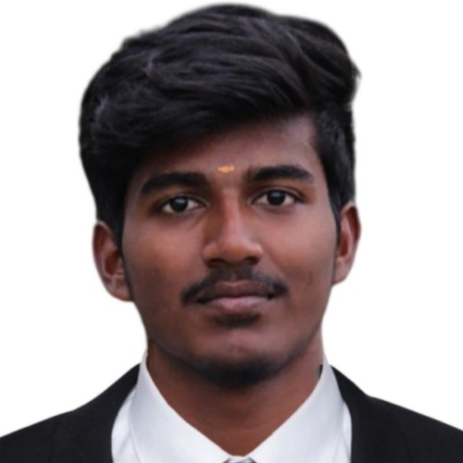@ [sridhar](mailto:sridhard2910@gmail.com)[d2910@gmail.com](mailto:d2910@gmail.com)

O 9677636402

, 6/363-23,Sri Sai Nagar,

Pethappampatti(po),Udumalpet (Tk),Tirupur

(Dt)-642 205

i https:/[/www.linkedin.com/in/sridhar-d-](http://www.linkedin.com/in/sridhar-d-) 4086481b4

OBJECTIVE

I seek challenging opportunities where I can fully use my skills for the success of the organization.

EDUCATION

2016-17

2018-19

2019-23



Government Higher Secondary School, Pethappampatti

SSLC 89%



Sri Kannika Parameshwari Higher Secondary School, Udumalpet

HSC 69%



PA College of Engineering and Technology, Pollachi

BE(Electronics and Communication Engineering) 8.94/10 (upto 5th semester)*

INTERESTS

Embedded systems Programming

Web development

SKILLS

C Programming Java (basics)

DBMS,SQL HTML,CSS



ACHIEVEMENTS & AWARDS

Participated in Project Fanfare and Foco Challenge entitled LED chaser, Pixel

Programming organized in Invictus,5th National level project contest conducted by IETE & IE(I) students forum at PA College of Engineering and Technology on 12th March 2020

ACTIVITIES

Attended a Webinar on "Principle Component Analysis" Conducted by Department of Mathematics,KPRIET on 6th June,2020

Attended a Webinar on "6th Wave of Innovation:Disruption" on 4th June 2020, Organised by Sri Eshwar College of Engineering and Technology,Coimbatore

I have successfully completed the Internship and Implant training in the ﬁeld of "CORE JAVA" in emglitz Technologies,Coimbatore

Member of IEI



COURSE COMPLETION

Successfully completed a course named "Foundations of Front end web development",Udemy

LANGUAGES

Tamil - L/S/R/W English - L/S/R/W Telugu - L/S

MINI PROJECTS

LED Chaser

Pixel Programming

SOFT SKILLS

Time management Communication

Flexibility Team work



PERSONAL DETAILS

Date of Birth : 29/10/2001 Father's Name : B.Dhanabal samy Mother'sName : D.Radha

Blood group : B+

HOBBIES

Traveling Book reading

DECLARATION

I hereby declared that all the information furnished above is true to the best of my belief